Setting up a Zoom Background

To upload the a new zoom background complete the following:
On the zoom toolbar once you have joined the meeting, Click the up arrow next to the start video icon. This will bring up a menu option.
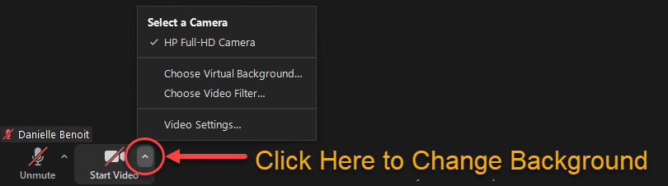

Select Choose Virtual Background… from the menu options.
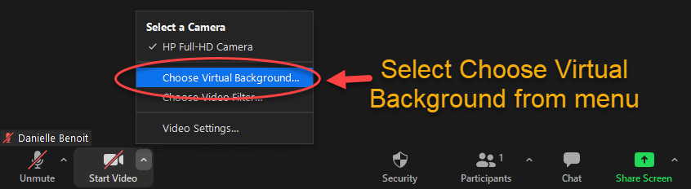
In the pop-up Settings window,
- Click the Plus sign (+) icon
- Select Add Image
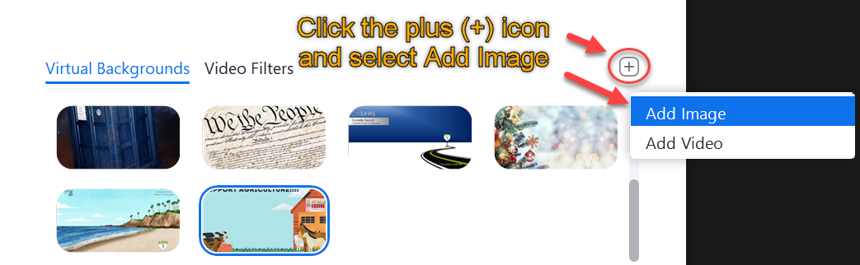

On the Choose a background image pop-up window:
- Select the location that you saved the “AAE Support AG_Zoom Background.png” file.
- Highlight file name “AAE Support AG_Zoom Background.png”
- Click Open.
The image will now be selected as your background and you will see it in the viewer above your uploaded files along with your video.
Note: This does not mean your video is viewable to others in the meeting.
To start your video and make it viewable to others in the meeting, click the start video icon on the zoom toolbar.
